1. INTRODUCTION:

1.1 Other view

House price prediction in a metropolitan city in india is a valuable solution for potential home buyers, real estate agents, and investors.

By leveraging historical sales data, property details, and location-specific information, a predictive model can accurately estimate house prices.

Property valution helps a buyer know the actual worth of the property and whether the sale price mentioned by the seller/owner is approprite or not.

1.2 Purpose

The house valution or property valuation holds immense importance for a buyer from the below-stated perspectives.  
 The model’s scalability, real-time updates, user-friendly interface, and transparency ensure it meets the needs of stake holds.

1. PROBLEM DEFINITION & DESIGNTHINKING:

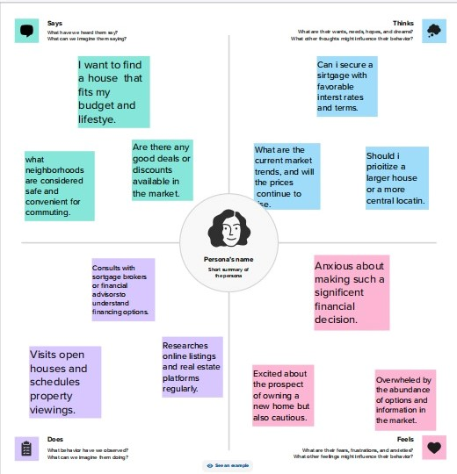2.1 Empathy Map

* 1. Ideation & Brainstorming Map

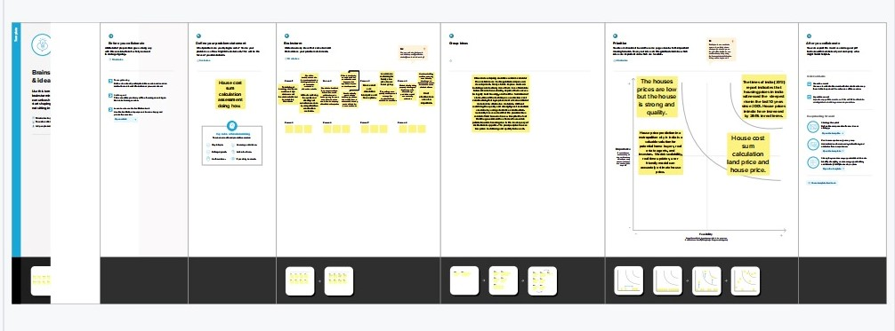

1. RESULT

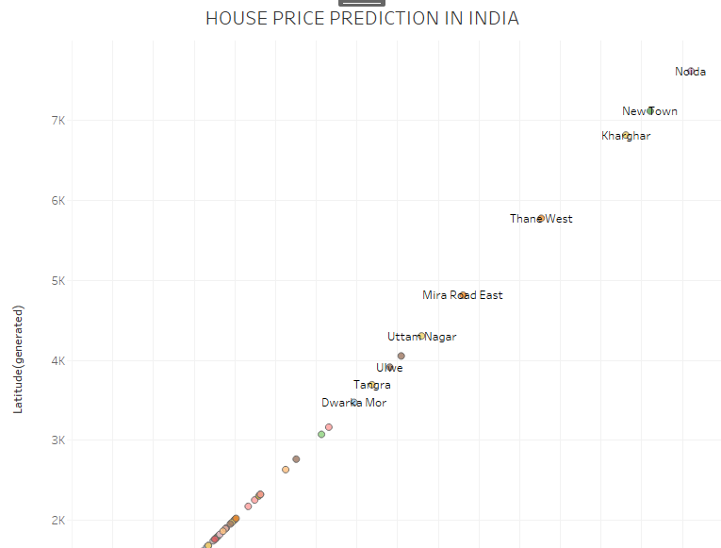

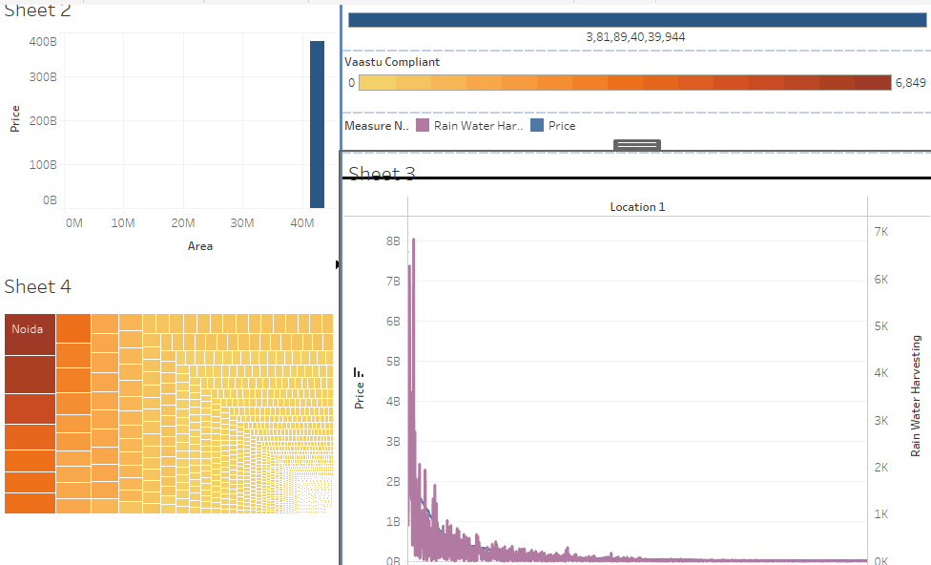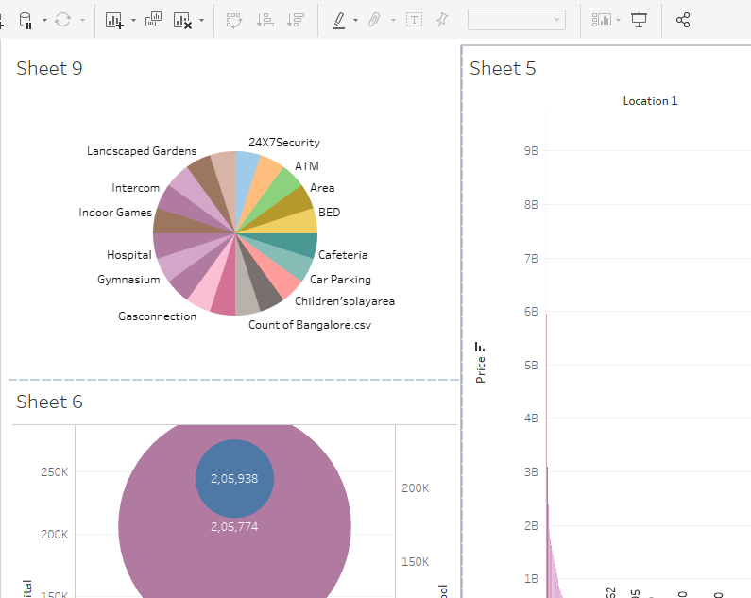

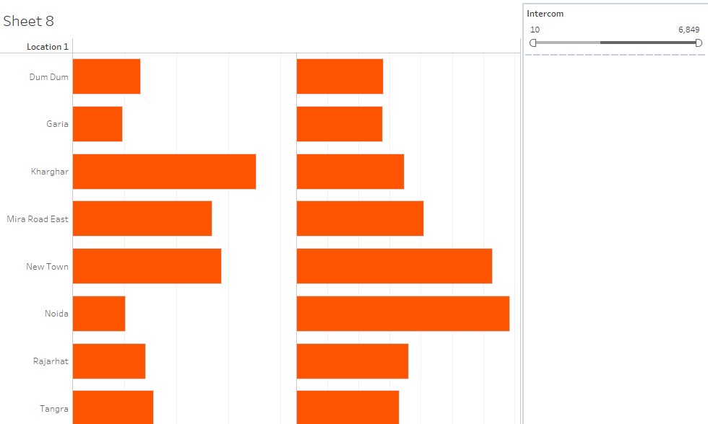

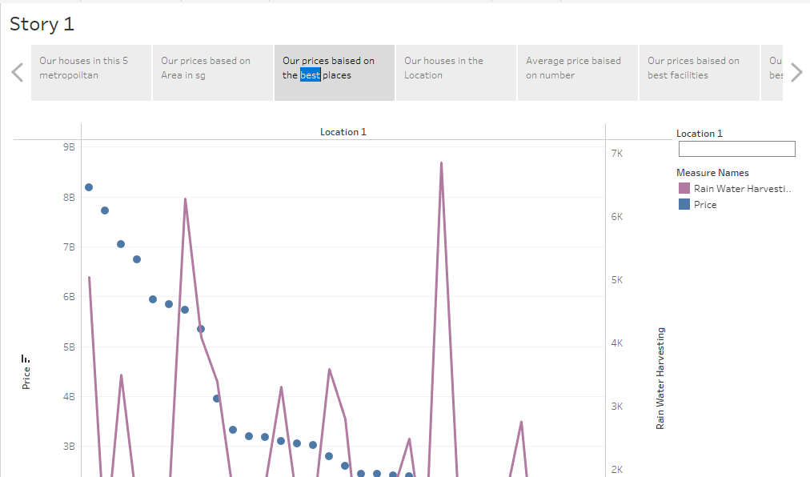

1. ADVANTAGES & DISADVANTAGES

Property valuation helps a buyer know the actual worth of the property and whether the sale price mentioned by the seller/owner is appropriate or not. Calculation land price and huse and things price is useful.

Empowering stake holders to make informed decisions in the fast-paced real estate market.

The houses price are low but the house is strong and quality. I want to find a house that fits by budget and lifestyle.

Are there any good details or discounts available.

1. APPLICATIONS

Number of houses based on area in sqf calculation. Houses price based on rainwater harvest pits and Vastu-complains based on location. House price based on Number of Bedrooms and Hospitals and schools near the Houses.

Manitains staff in houses prices house price and income and all services based on locations.

A metropolitan area is a region house to a densely populated urban core and its less-populated surrounding territories, sharing industry, infrastructure, and housing.

House price prediction in a metropolitan city in India is a valuable solution for potential home buyers, real estate agents, and investors.

Social listening analytics will be a must have for every marketing.

1. CONCLUSION

A resilient model is not always the same as an optimal model in this research a model that frequently employs a learning approach that is inappropriate for the current data format .

The Analysing Housing Area is Metropolitan of India is very use full are the younger’s future help.

By leveraging these business can make strategic decisions that not only lead to profitability but also foster innovation, customer satisfaction, and sustainable growth.

1. FUTURE SCORE

This reason is because real estate prices in india are driven by builders and not by buyers. Land prices are hugely inflated, in large part because of unaccounted money being pumped into it.

Affordable housing refers to dwellings that are accessible to families/individuals with household income below the median household income. So future the public peoples are use for helps this is my future.

1. APPENDIX

https://www.kaggle.com/abhinand05/crop-production-in-idia